Platelet distribution in pipe

*In blood flow, the concentration is higher near the vessel wall. This caused by the size and shape difference between the larger red blood cells and the smaller platelets. The validation of the simulated platelet distribution based on Aarts et all [1] works.*

# Simulation:

* stationary (Poiseuille-profile, laminar flow)
* flow between two infinite planes (pipe_long), diameter: 3.09 [mm]
* 240 [1/s] shear velocity near the wall (depends on Re-number )

In the medFlow2D program there are two parameters, which have effect on the platelet distribution: margForcRatio and psDiffusion.

Program setup:

|  |  |
| --- | --- |
| xRes=2.89337e-5 | Re=115.3 |
| viscosity=3.4e-6 | psDiffusion=2.5e-7 |
| density=1025 | margForceRatio=0.1 |

Due the stationary simulation, the velocity inlet is constant, so in the *inletScale.txt* file the data should be looks like this:

|  |  |
| --- | --- |
| 2 |  |
| 0 | 1.0 |
| 1 | 1.0 |

# **Result**s:

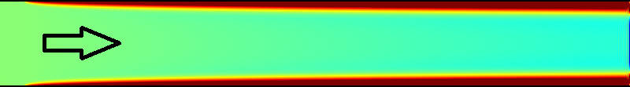

Figure 1 Platelet distribution in the geometry. The higher concentration is near the wall.

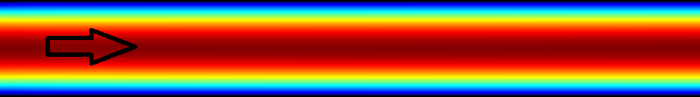

Figure 2 Velocity field at Re=115.3 (240 [1/s] shear velocity next to the wall).

# Validation

The simulated concentration distribution was at haematocrit of 0,6. The literary distribution can be seen in *Aarts et all* [1] works, on Figure3 C. To compare the two distribution, the literary values divided by the largest value (to get the relative concentrations), and the simulated data transformed by the (1) equation.

|  |  |
| --- | --- |
| $$x_{tr}=\left(\frac{x}{x_{max}^{sim}}-1\right)∙\frac{x_{min}^{ref}}{x_{min}^{sim}}+1=\left(\frac{x_{min}^{ref}}{{x_{min}^{sim}∙x}_{min}^{sim}}\right)∙x-\frac{x_{min}^{ref}}{x_{min}^{sim}}+1$$ | (1) |

where:

$x_{tr}$– the transformed relative platelet concentration

$x_{min}^{ref}$– the lowest value in the reference relative platelets concentration

$x_{min}^{sim}-$ the lowest value in the simulated platelets concentration

$x_{max}^{sim}-$ the highest value in the simulated platelets concentration

$x-$ the simulated platelet concentration value

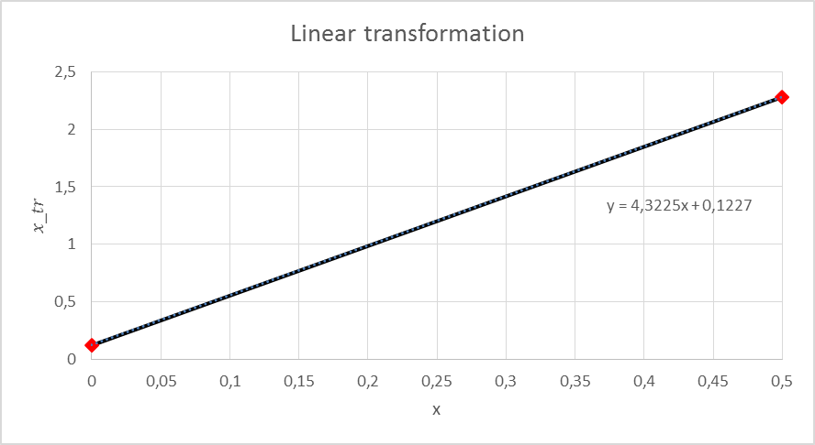

Figure 3 The linear transformation of the simulation data.

The simulation time was 2 [s], and the examined cross-section was at the middle of the geometry. The Figure 4 shows the simulated and the literary (reference) platelet profiles. The distributions are very close to each other, and the difference between these curves can be minimized with the parameters refining.

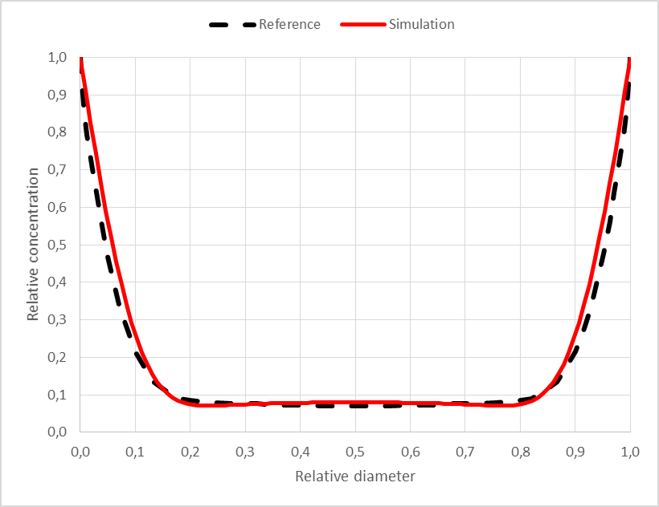

Figure 4 Platelets concentration distribution across the diameter at 240 [1/s] shear velocity.

[1] Piet A.M.M. Aarts, Sjaak AT. van den Broek, Gerrit W. Prins, Gerard D.C. Kuiken, Jan J. Sixma, and Robert M. Heethaar (1988): Blood Platelets Are Concentrated near the Wall and Red Blood Cells, in the Center in Flowing